**Regular Expressions**

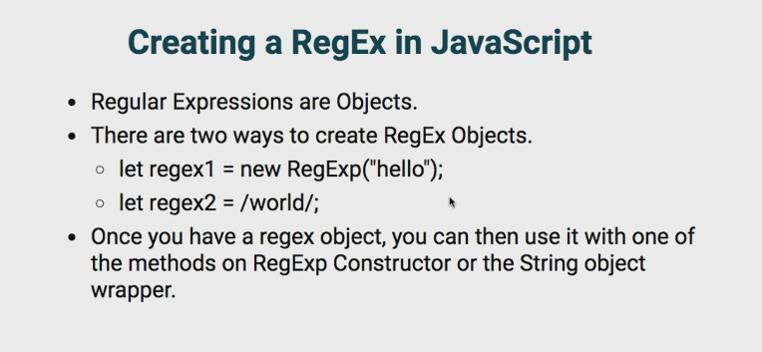

var text = "Programming is simple to learn";

var regex1 = new RegExp("simple");

var regex2 = /learn/;

console.log(regex1.test(text)); //true

console.log(regex2.test(text)); //true

In above example we create a Regular Expression pattern using regular expression constructor and literal,

1. Using RegExp() constructor just pass the string
2. Literal syntax using forward and backword slash, / 🡪 beginning of pattern and /--> end of the pattern, no need to put double quotes.
3. test() is the RegExp method to test regular expression pattern with given string, it return Boolean value for success and failure.

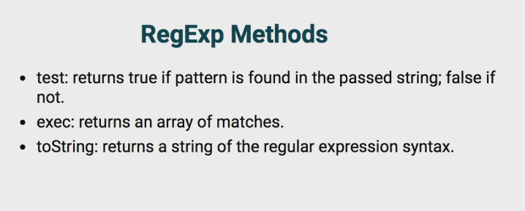

var text = "start Javascript, start RegExe";

var regex = /start/;

console.log(regex.test(text)); //true

console.log(regex.toString(text)); // '/start/'

console.log(regex.exec(text));

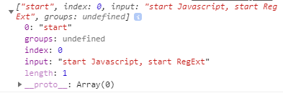

**exec()** method returns an array of match,   
 first index holds the search string.  
 second is index object which holds the starting index of search pattern in given string.  
 third holds entire string.

Note: it return first occurrence only.

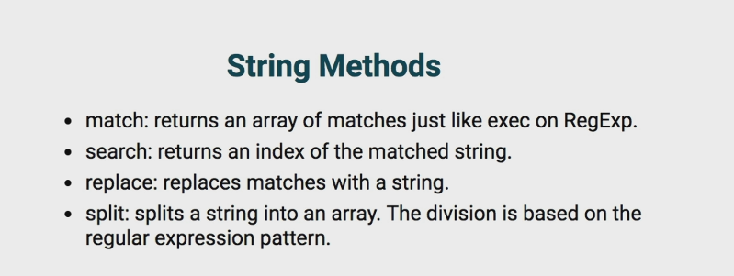

var text = "start Javascript, start RegExe";

var regex = /start/;

console.log(text.match("start")); //["start", index: 0, input: "start Javascript, start RegExe", groups: undefined]

//or

console.log(text.match(regex)); //["start", index: 0, input: "start Javascript, start RegExe", groups: undefined]

console.log(text.search("start")); //0

//or

console.log(text.search(regex)); //0

console.log(text.replace("start","hi")); //hi Javascript, start RegExe

//or

console.log(text.replace(regex,"hi")); //hi Javascript, start RegExe

console.log(text.split(",")); //["start Javascript", " start RegExe"]

//or

console.log(text.split(regex)); //["", " Javascript, ", " RegExe"]

**\S in regular expression “\s” for empty space**

var text = "start Javascript, start RegExe";

var regex = /\s/;

console.log(text.split(regex)); //["start","Javascript,","start","RegExe"]

**Regular expression flags**

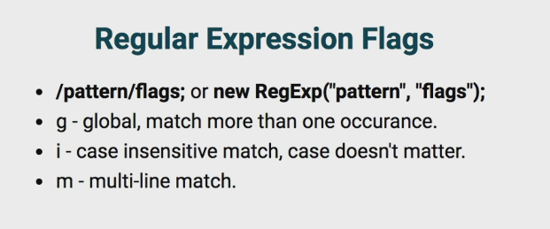

var text = "Programming always starts with Hellow'S world";

var regex1 = /s\s/;

console.log(text.match(regex1)); //["s "]

var regex2 = /s\s/g;

console.log(text.match(regex2)); //["s ","s "]

var regex3 = /s\s/gi;

console.log(text.match(regex3)); //["s ","s ","S "]

**exec() and match() are same better use match() method.**

In above example we are created a pattern for s character followed by space,

Regex1:- returns single occurrence of given pattern   
Regex2:- returns multiple occurrence of given pattern, we added “g” flag

Regex3:- returns multiple occurrence of given pattern of case sensitive, we added “i” flag

**Metacharacters in regular Expressions**

WildCard character

1. whild card character is represented by .(dot)
2. whildcard (.)can be anything except new line.
3. .(dot) character represent any single character

Eg1:- dot will be replaced by any character but not new line

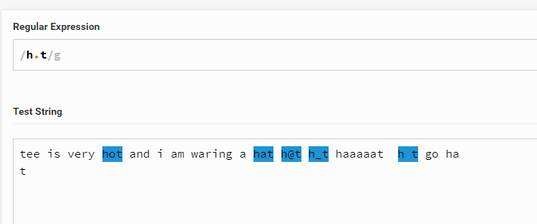

Eg2:- each dot represent a character

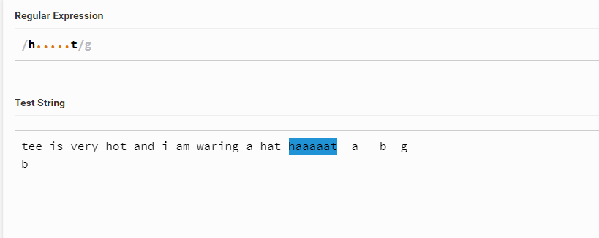

Eg3:- \t for tab

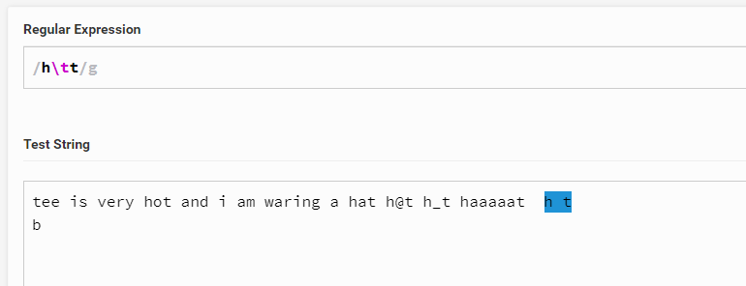

Eg4:- \n for new line

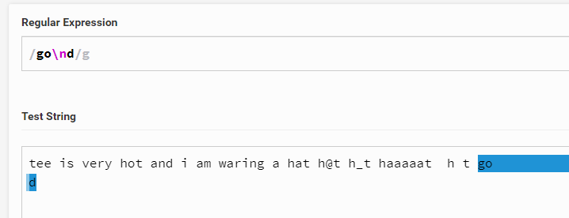

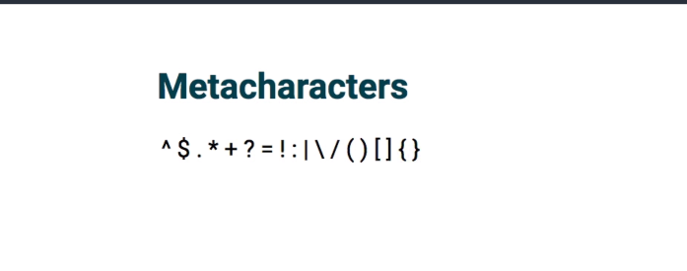

**Escape character**

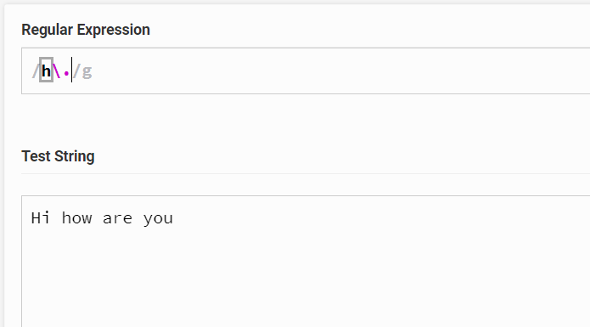

We are using escape character \ , so no text got selected here because after h it try to find dot(.) character.

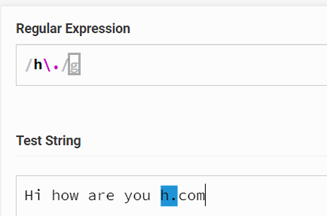

Above example it finds the match.

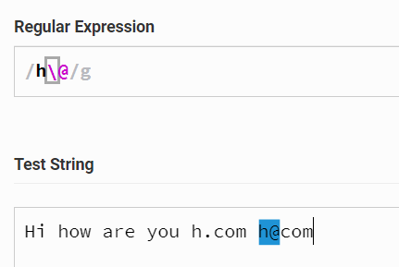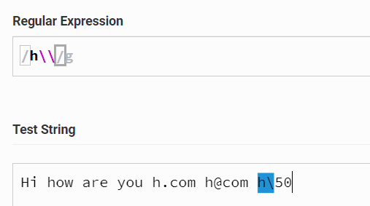

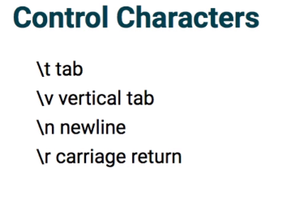

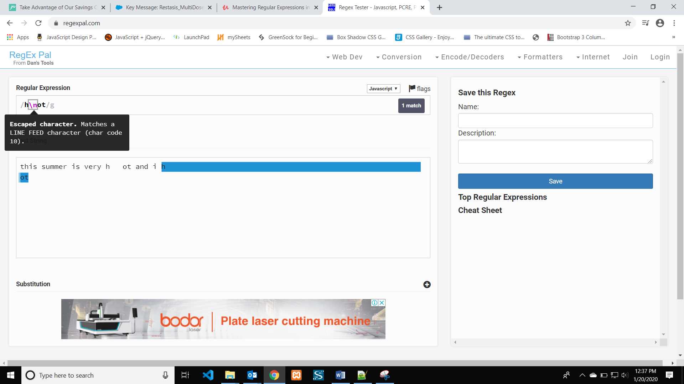

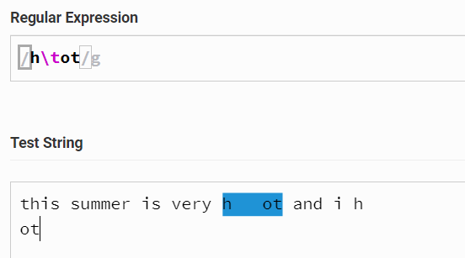

**Character set(group of character)**

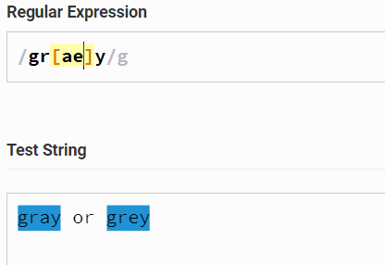

A group of character in side a square bracket will try to match next character after “gr” [] targets only one character.

Character inside [] try to match any one character inside the bracket not all.

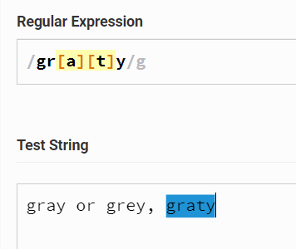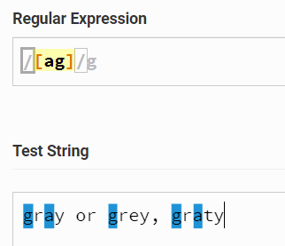

After any character eighter “a” or “g” try to match “y” has next character

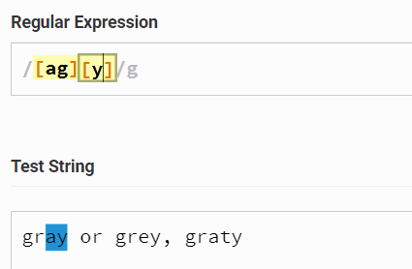

First it finds character “a” second it try to match “a” or “g” third match tied is “e” fourth match eighter empty space or “5” or “0”

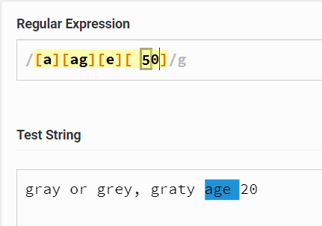

From entire string it try to match “1” or “2” or “3” or “4”

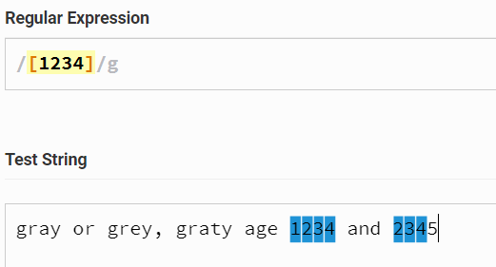

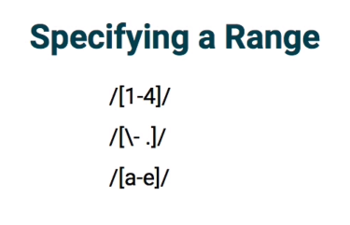

[1-4] try to match “1” or “2” or “3” or “4” it specify the range.

Inside character set – indicates range.

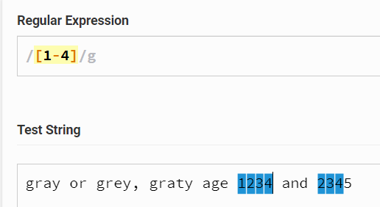

Above example character set try to match “1” or “2” or “3” or “4”, but not “1” or ”-” or “4”  
-(hyphen) inside a meta character set is exceptional its not treated has separate character.   
hyphen stands for range inside metacharacter set.

Still you want to use hyphen has character set than go for escape character.

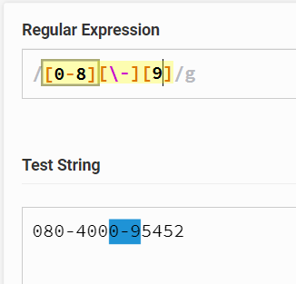

Check each character in the given string, if that character matches from 1 to 7 it matches  
two match found.

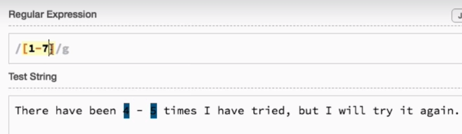

Because it checks for individual characters. Ie two match found

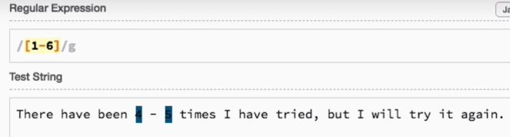

One match found

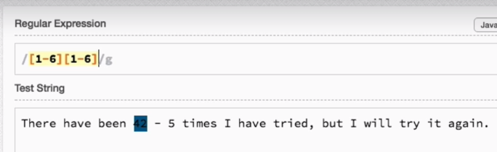

We can match multiple range inside braces, here multiple matches found. It checks each character for multiple range ie 1 to six and a to z

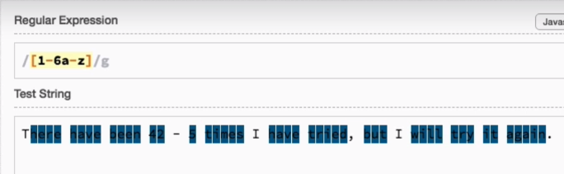

Upper characters also included

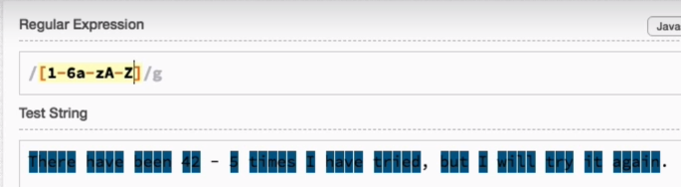

**We have multipe range 1 to 6, a to z and upper case A to Z  
One important point here is even hypen got matched, if we use hypen between any character or numbers it will considered as range, if it is used saparately it will consider as a character.**

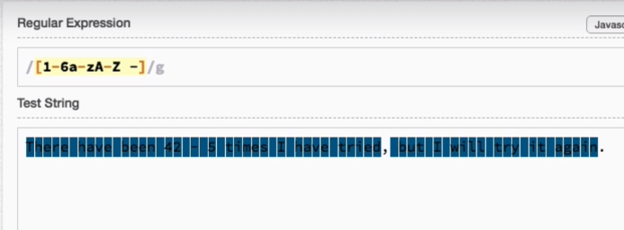

We are searching character “1” or “2” followed by –(hyphen) and “5”, **no range here**

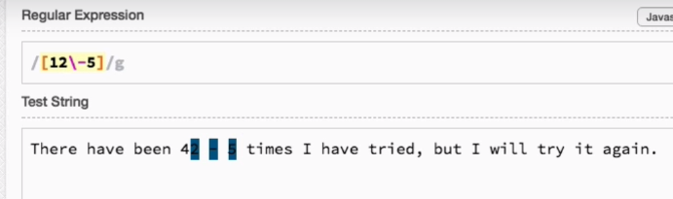

Trying to match “-” or “,” or “.”

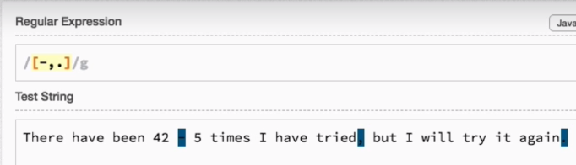

After “0x” select range 0-9 or A-F followed by range 0-9 or A-F

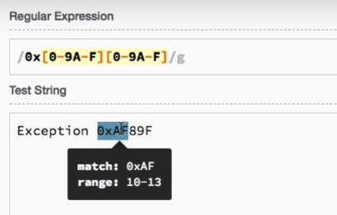

**Here number is not selected for range 10 to 20, here it search for range “0” to “2”**

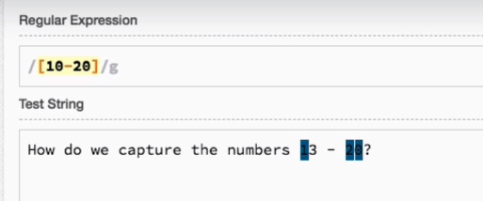

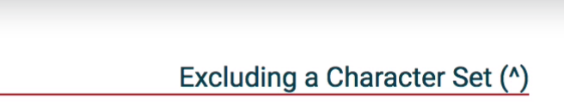

The group of character we don’t want to include in the match.   
use ^ symbol at the beginning of the character set only.  
^ symbol just negate the search result ie it is similar to ! in js.

After “0x” followed by the character which is not in range of 0-9 and A-F but next character is “F” it matches so no selection is made here.

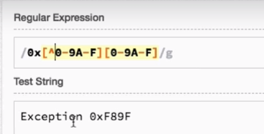

Selection is made.

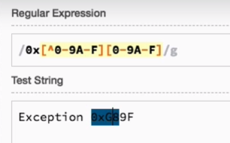

It checks for the character which is not in the range a-z, so not match.

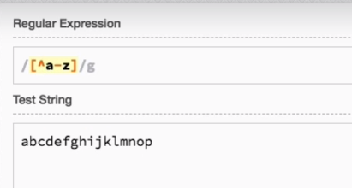

Here search for carrot symol and range a-z, so all characters or selected  
to make carrot symbol has a character use escape character for carrot symbol.

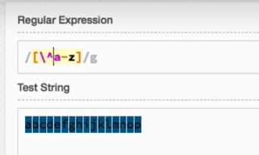

If we use carrot symbol at the end of the match it will treated as normal character.  
search for character from a-z and carrot symbol.

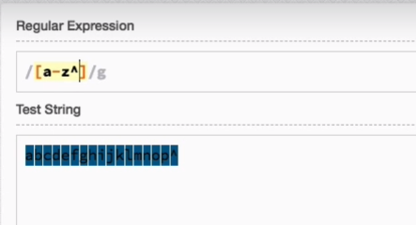

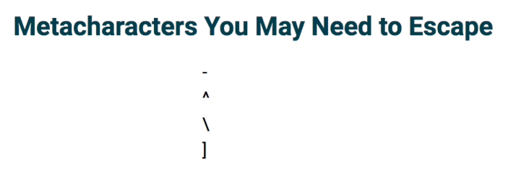

Shortand for character set ie you can replace /[0-9]/g by /\d/g  
\s represend sapce and tab and carry return and new line

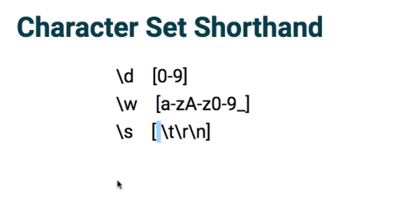

This is same as /[0-9]/g

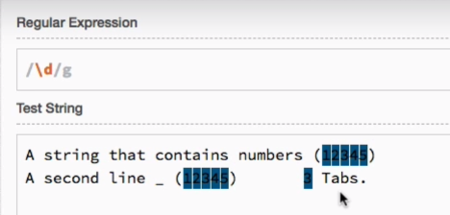

This is same as /[a-zA-Z0-9_]/

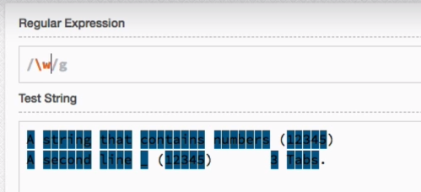

This is same as /[ \n\t\r]/g which incluseds space, newline, carry return and tab.

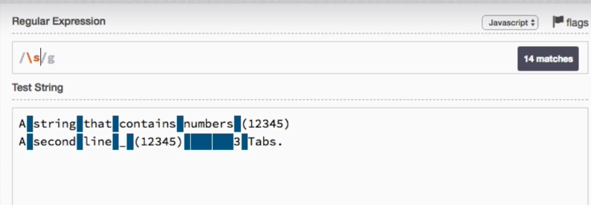

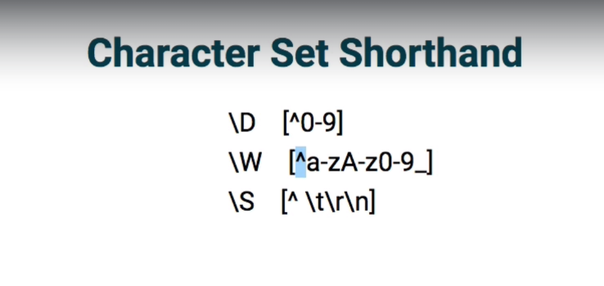

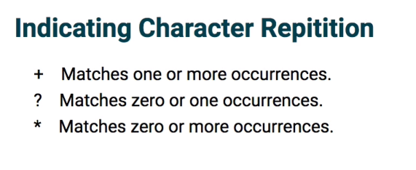

At times you need to character to repeat to find a match. Reg Exp come up with three meta character which indicate which item to repeat and how many times should it repeat.

**Add this character(+, *, ?) just after the character set which you want to repeat** ie if I am checking for a string below

/ph[a-z]/g  
so I want to repeat [a-z] for a search so add /ph[a-z]*/

Search for ph and after that a single chracter range form a-z

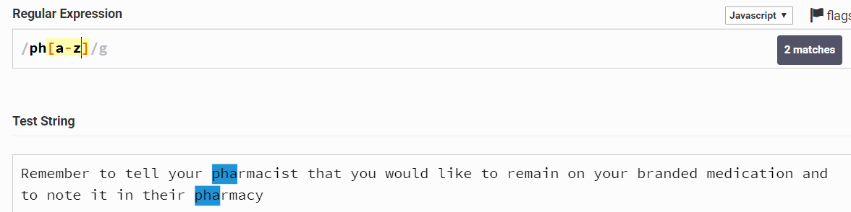

If I add plus repeat character after [a-z], [a-z] repeats until it fails. Plus symbol indicates one or more occurrence of [a-z].

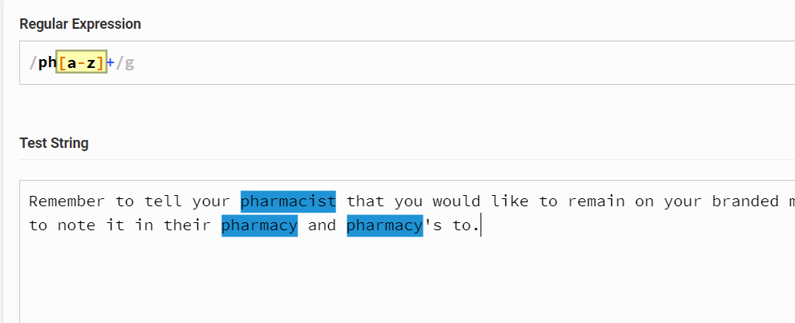

Which repeat the search for [a-z] until it fails.

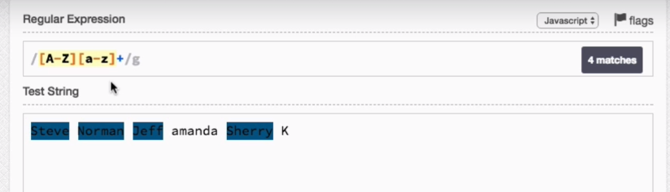

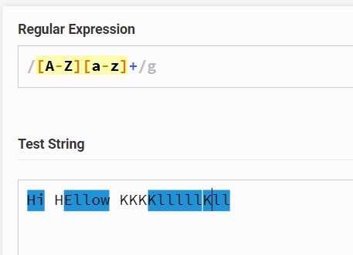

Only difference with plus character is * search for zero or more occurrence.

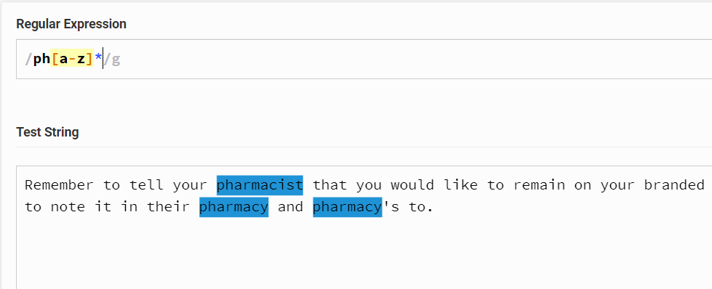

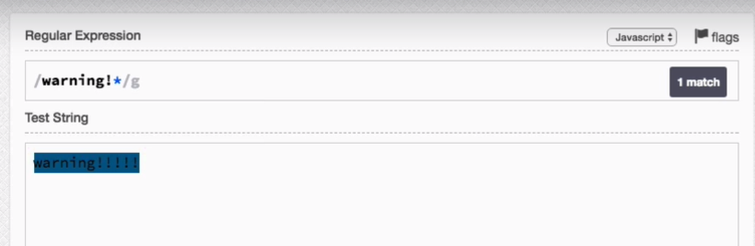

Question mark(?) zero or one occurrence.

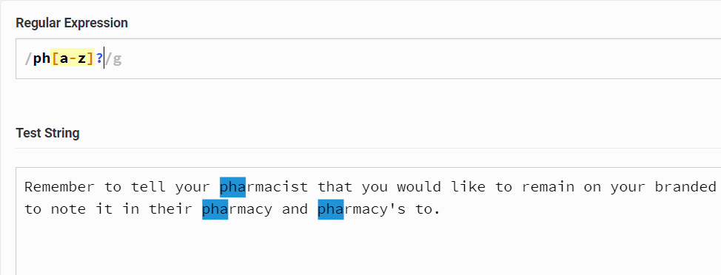

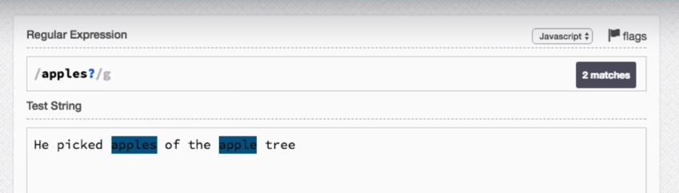

**Difference between * and +**

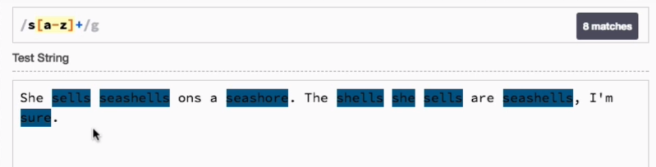

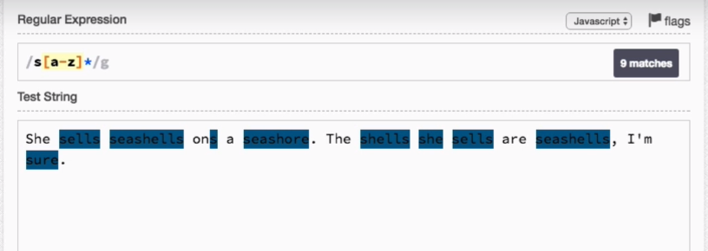



By default Reg exp are greedy ie they try to match as much as character possible.

Best example for greediness first <p> begenning second wildcard third is repeate character fourt end of search ie </p>  
what it douse is it starts form <p> and it finds whildcard any character later it finds * repeate character by greedy it select all the character till the end ie untill it reaches new line.

After that it finds </p> tag and start to search </p> form reverce order and it finds </p> at line end so it select entire line.

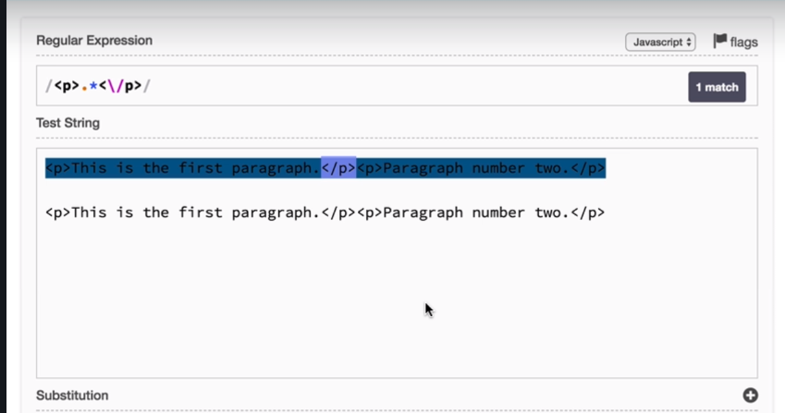

Hear no end character but still it’s a free selection till end.

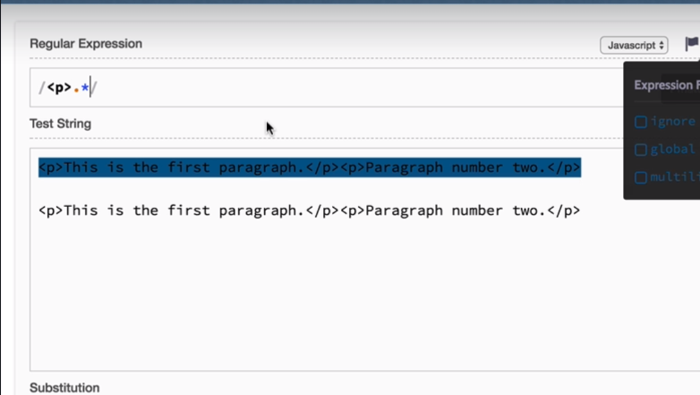

**Make it lazy by adding (?)**

So how lazy approach works first it matches <p> and it finds whildcard and * after that question mark, when it finds the question mark it try to match the end character(</p>) for each and every character, when it finds the ending character it stops the search.

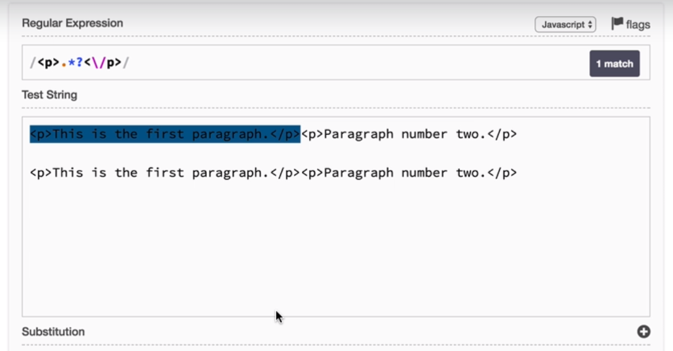

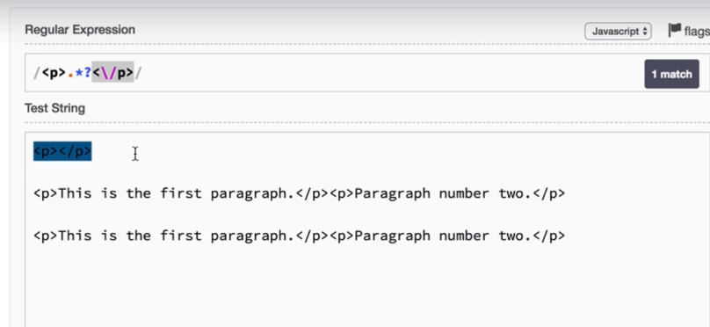

Here no end character beginning will be the end character

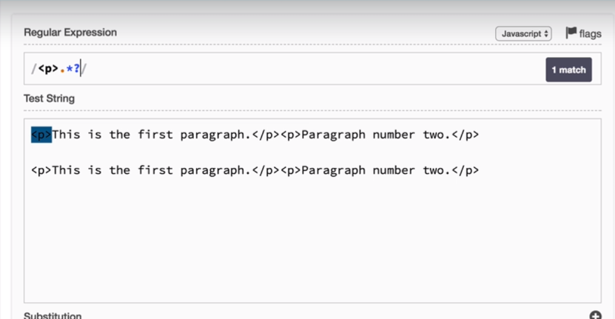



We use curly braces for specify the repition amount.

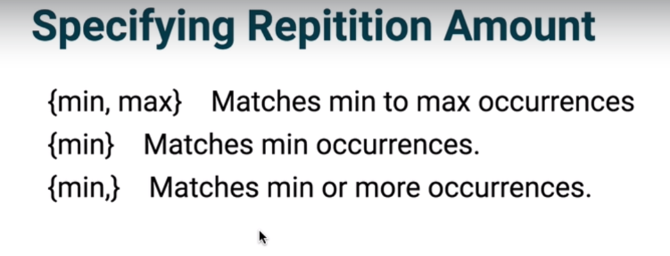

So it select word min = 3 and max = 5, not below 3 and not above 5.

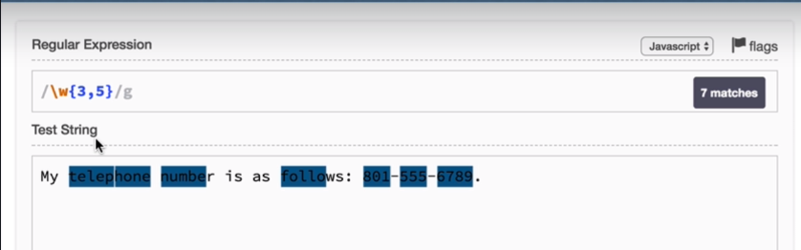

Below example we used \w\w twice so min = 4 and max = 6,  
why because it has to match one for first \w and three for second \w.

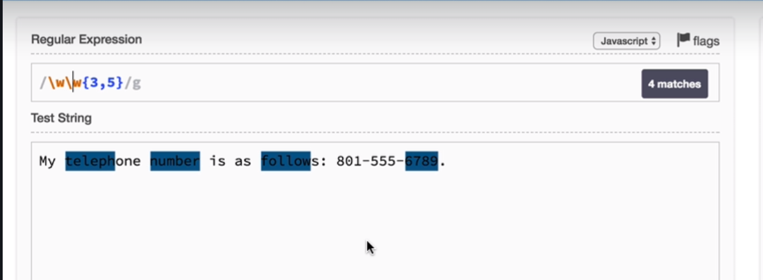

Its three or move, not less than three

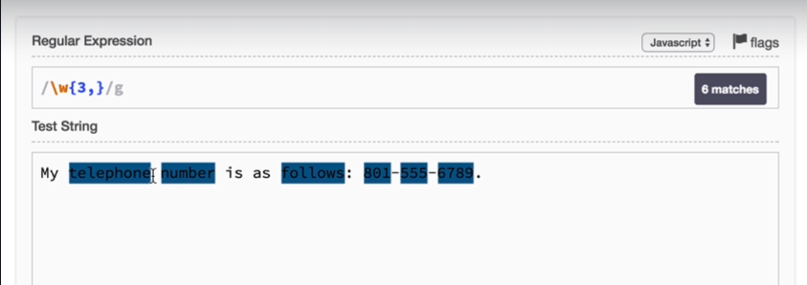

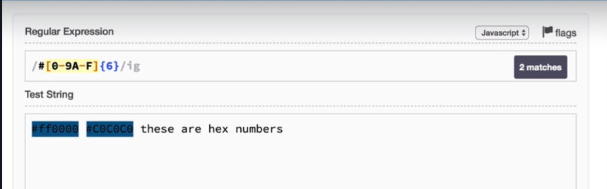

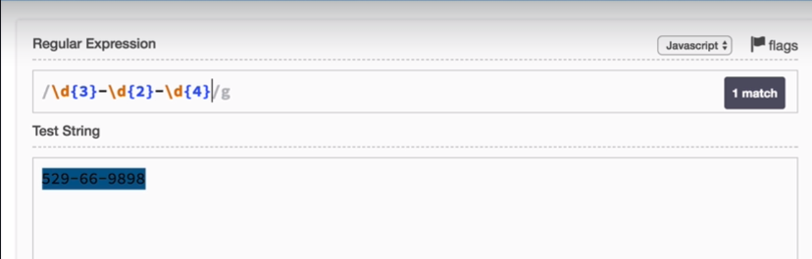

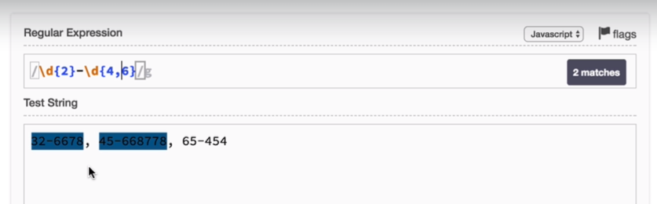

Make selction lazy, so when we add ? it consider min value and ignores the max val.

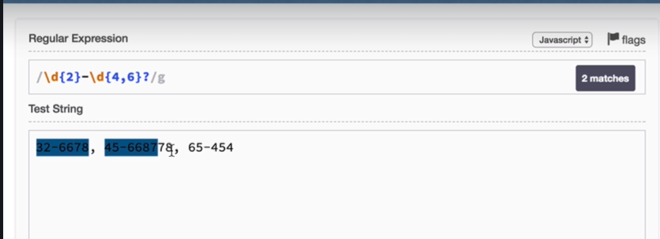

We added ? but still it select digits upto hyphen,  
why because when we add hyphen at the end it targets min value and search for hyphen for next digit it 5th (7) it check the range between min and max so it fall between min and max and it adds for the selection same o till it finds the hyphen.

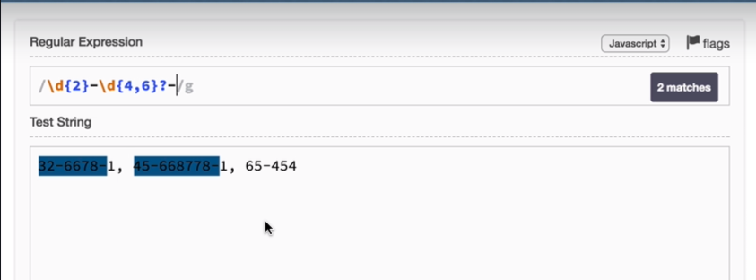

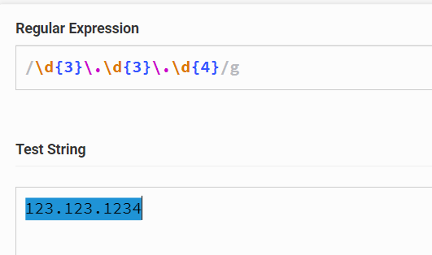

? repitation character for selecting zero or one occurrence

\(? 🡪 Use open “\(” brace with escape character, followed by question mark which says open “(“ brace can be exist or may not exist.

Followed by three digit match, escape character for closing brace and question mark saying closing brace may or may not exist.

[-.]? 🡪 character set for hyphen and dot operator ie any one can be matched and a question mark says hyphen or dot can be or can not be exist.

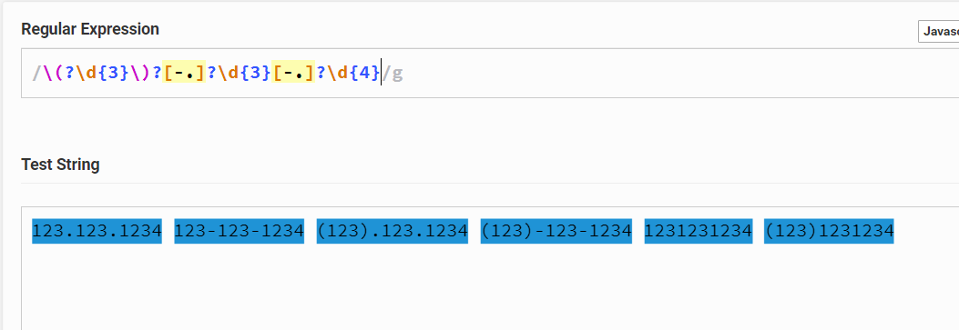

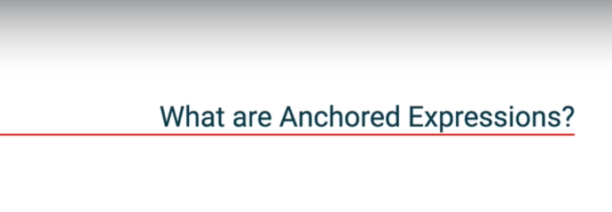

Regular expression pattern for targeting a character or string at the end or beginning and even in between string suing Anchored Expressions.

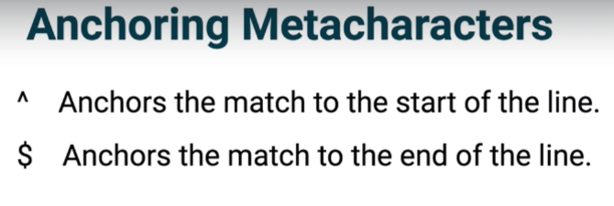

^ Carrot metacharacter targets beginning of the line.

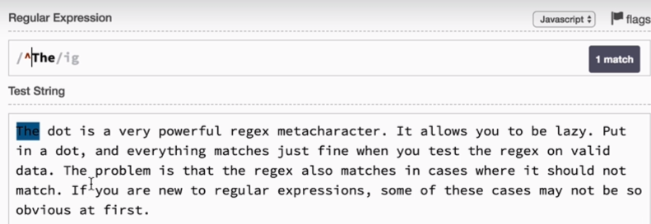

$ metacharacter at the end specifies the selection at the end of the given string.

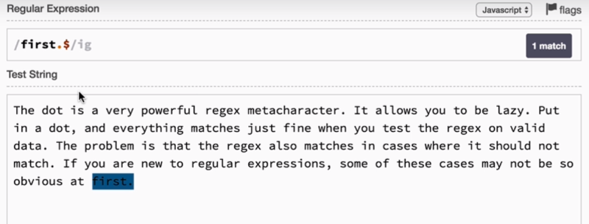

If we use both metacharacter it targets the string which start and end string is “first.” When this is possible, only when given string is same for staring and end of the string.

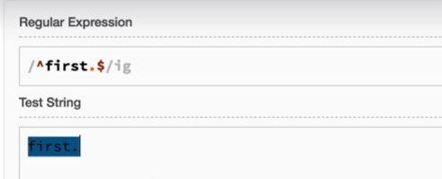

If we add multiline mode with $ character at end it tries to match dot(.) at end of each line.

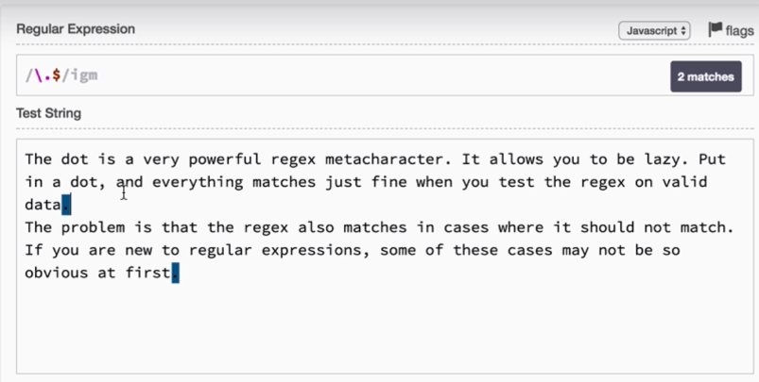

If we add multiline mode with ^ character at beginning, it tries to match “The” at beginning of each line.

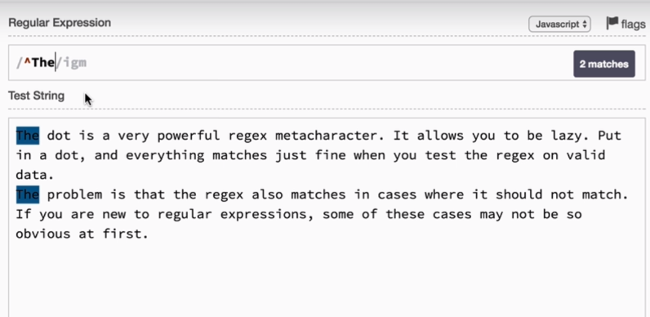

In this case no match is heighlighted because last line is empty not before that.

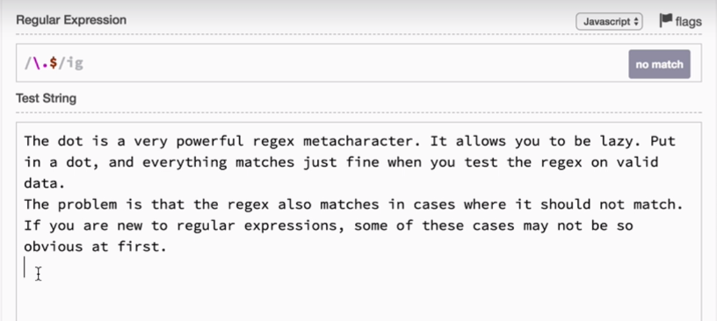

In this example you can observe that “other” string is highlighted at end of each line ie a line ends when we return from the last string of the para(by pressing enter key and move to next line)

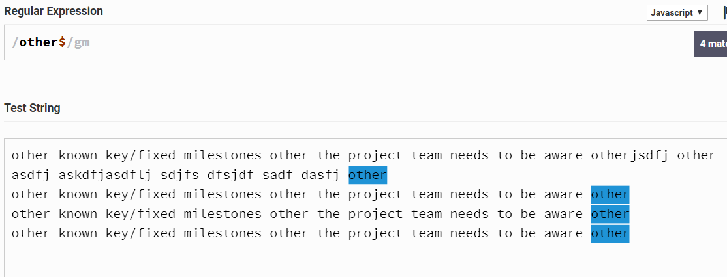



This metacharacter use to find boundary of a word.

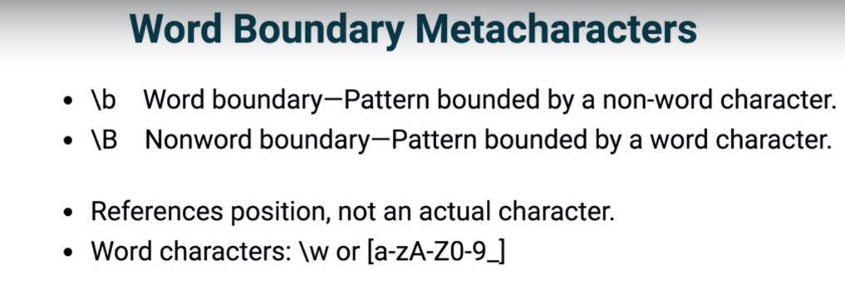

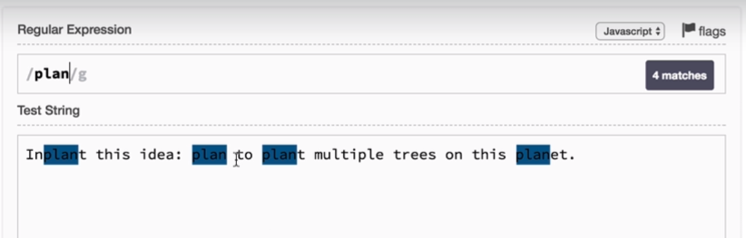

\b word boundary says that “Pattern bounded by a non-word character” ie it try to match the given string in which the given string should bounded(surrounded) by non word character like space, * / etc… in the below example “plant” and “planet” is not highlighted because this two words bounded by word characters.

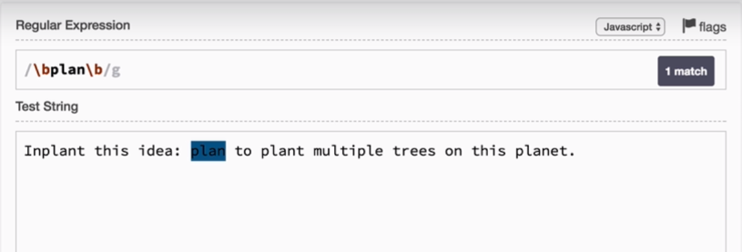

Still we want to use non word characters in search we can use like below example.

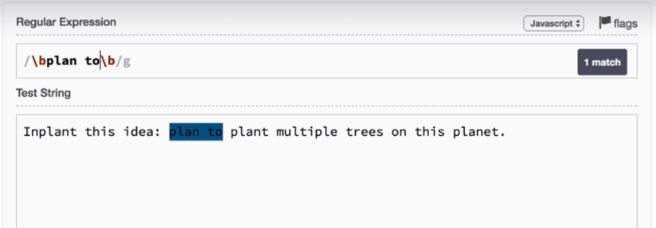

Global selection.

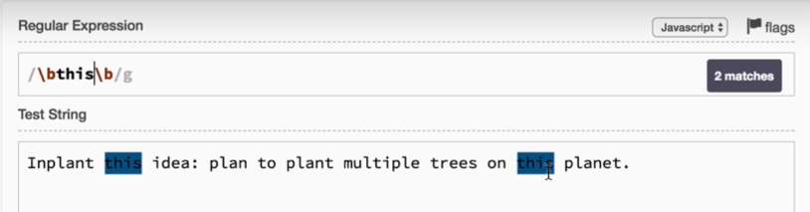

\B word boundary says that “Pattern bounded by a word character” ie it try to match the given string in which the given string should bounded(surrounded) by word character.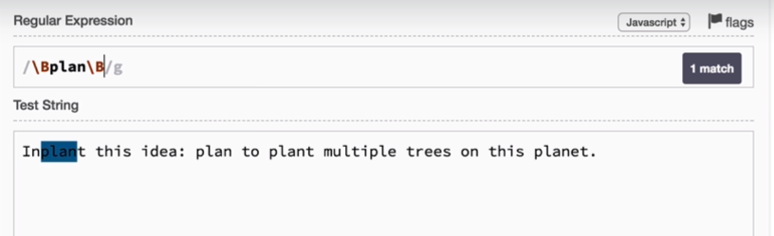

This is the best example for use of Anchors, what the below example says that match 5 numeric characters only. ^ says beginning 5 char only and $ says end 5 char only. So we are narrowing the expression for error free.

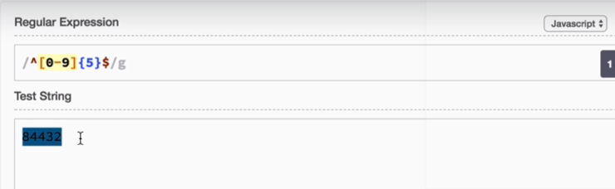

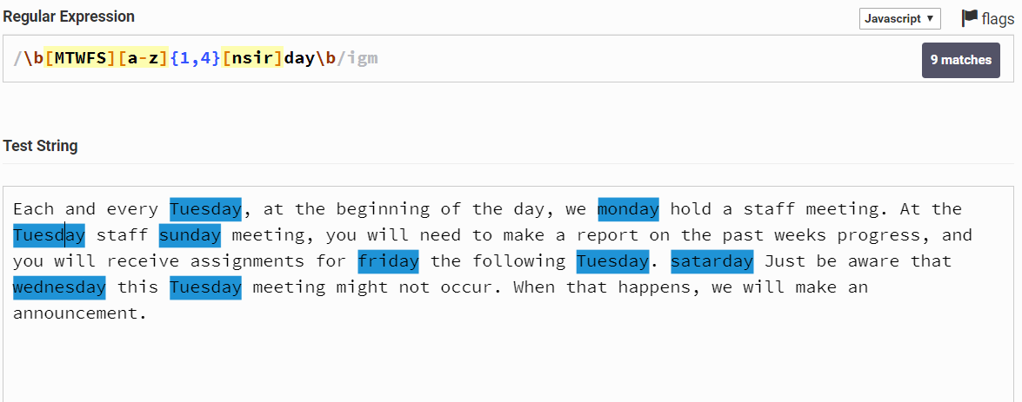

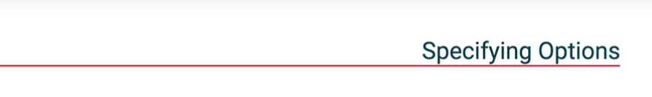

PIPE symbol:- The pipe symbol splits Reg Exp to multiple alternatives.   
pipe symbol in reg exp is or (||) in JS.

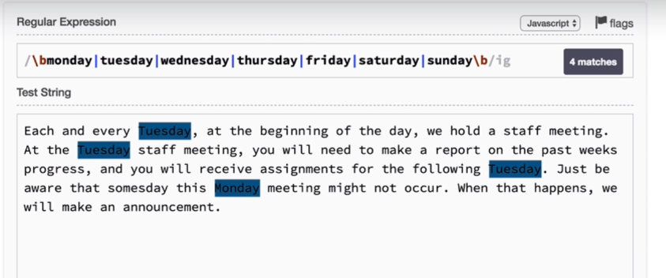

We can use filter like below with bound

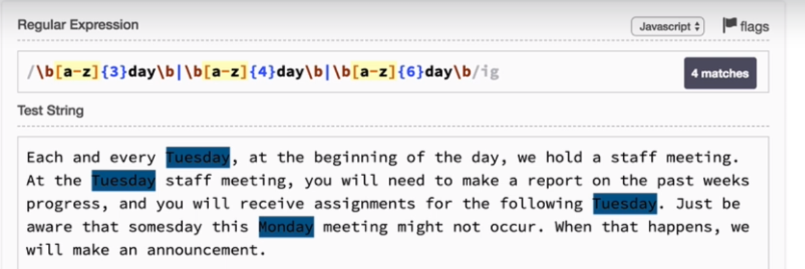

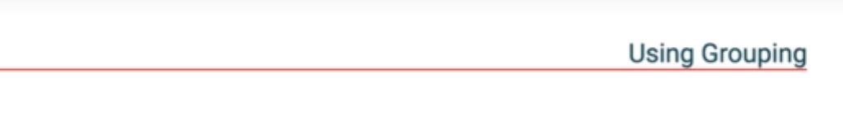

Grouping in Reg Exp done by using prentices “( )”.  
 prentices in JS used for precedence same in Reg exp as well.

Below example we want to match for a scenario text(a to d) followed by number(1 to 5) and group it

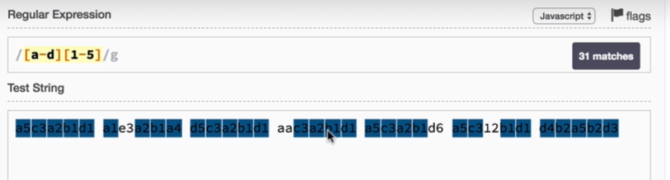

Below pattern won’t work because {5} only apply to [1-5] not for [a-d], because repitation applies to left most character set.

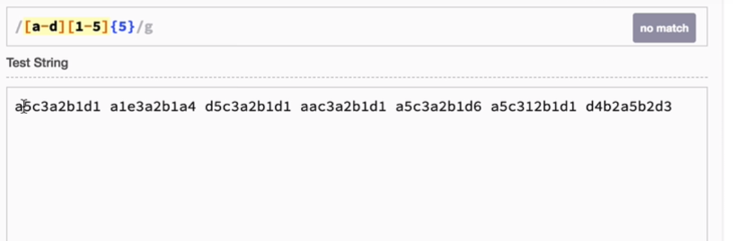

To over come this problem we will use grouping. Here grouping help us to add repitaion to multiple scenario.

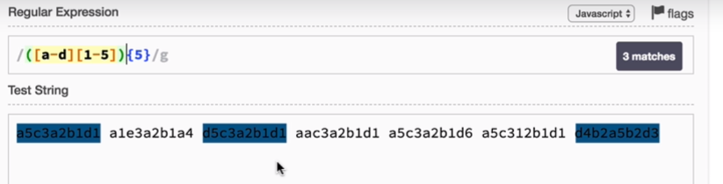

In below example we need to have a combination of acharacter and followed by number for 5 repitation.

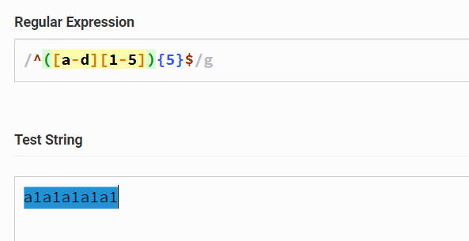

With out grouping this is the result, word bound will be applied to Monday and Wednesday only not for Tuesday that’s why Tuesdays is also getting selected.

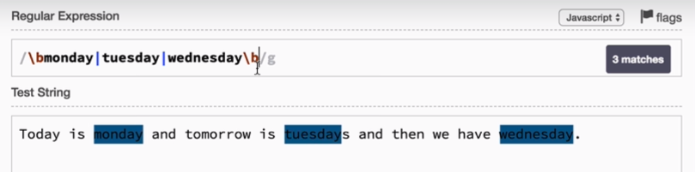

To over come this problem we can use grouping, when we apply grouping word bound will apply to all the pattren inside the group.

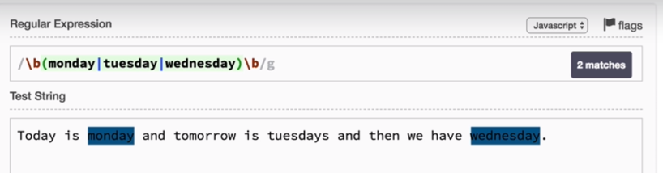

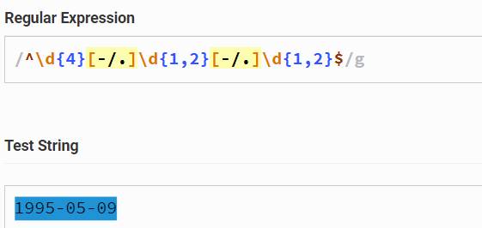

Same example using group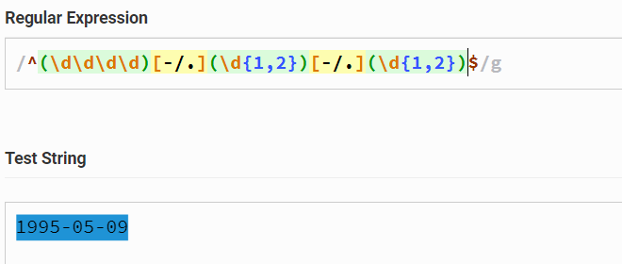

By using grouping we can saparate data using exec() method, so what exec() method dous is it divide data with respect to group and store it an array.

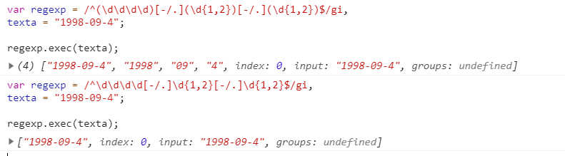

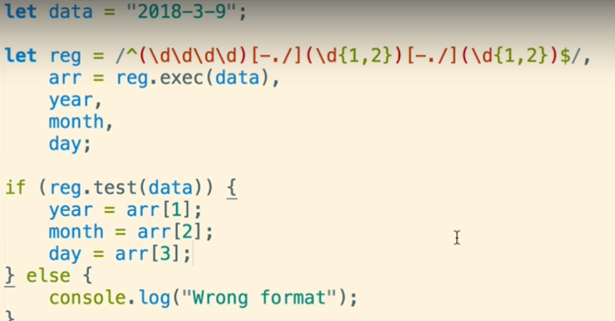

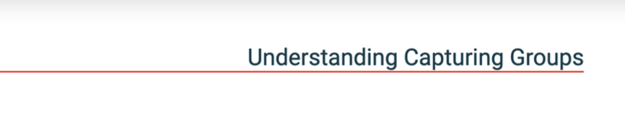

Open and close parenthesis in Reg exp creates a group not only we can create a group even it allows the portion to reuse it later.

From the below example we can notice that (\d{1,2}) is repeated twice so we can avoid this in next example.

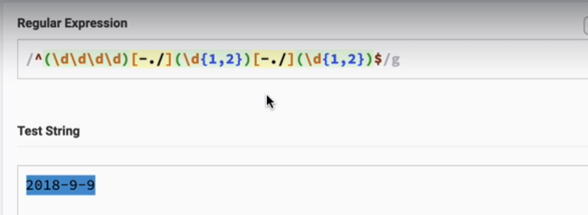

We can use \order-of-group, in below example last repeate is replace by \2   
2 because the group which we cant to capture is second group. so we have proper match

**Note:- by using \order-of-group not grabbing the the pattren but its is grabbing the result text.**

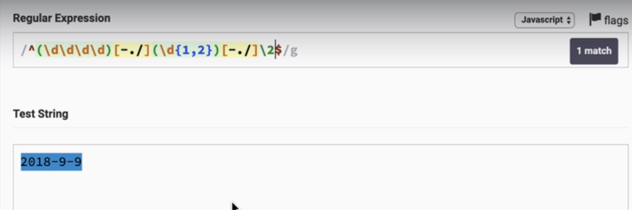

Below example match is not happening because second group is (\d{1,2}) and the result test of given example is “9”, so \2 takes text ie it takes 9 not pattern.  
so it try to match number 9 to 8 condition fails.

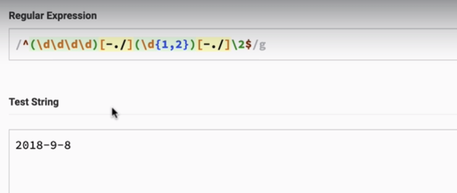

So in above example we have [-./] has common lets make it common by adding it to group and use \2 as the capturing group. (\2 its second group from left)  
  
we can see one more catch here when I input 2018-9/8 matching fails. Because \2 takes pattern value not pattern, pattern value is – in below example. This is the best example for standard common pattern.

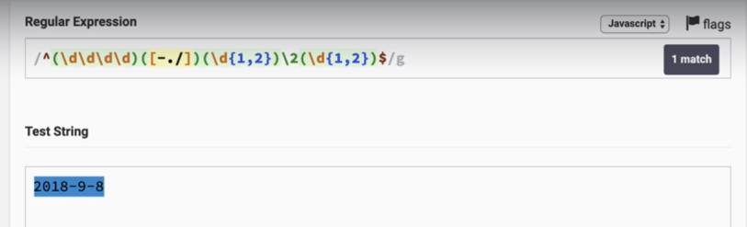

By default groups are capturing, We can make non-capturing by adding ?: inside group.  
below example we made first group is non-capturing by adding ?: and you can observe \2 changed to \1, because group one is no more capture group and group one is ([-./])

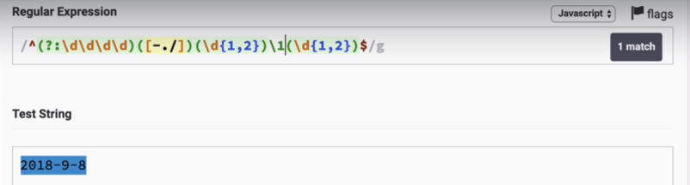

If we make a group non-capturable and use exec() to extract the group we fail doing it for non-capturable group.

When to make group capturable and non-capturable?  
If we know that we are not using this group reference further in the pattern we can make that group non-capturable.  
if we make any group non-capturable in between order of group reference will be disturbed.



Here “\1” refer to “a1” text but not the pattren, so no match.

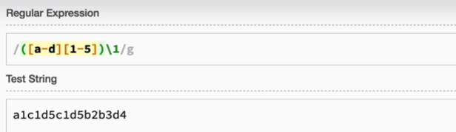

So if we add “a1” then we will have a match, below example work like this **/([a-d][1-5]) ([a-d][1-5])/**

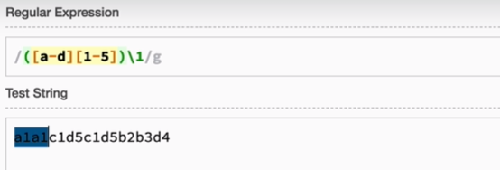

When we make non capturing group result is no match.

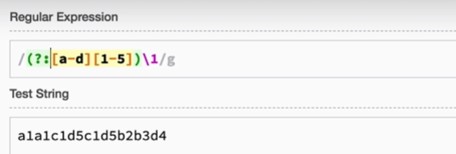

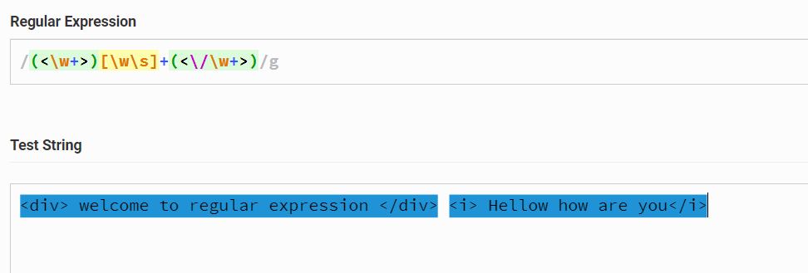

Better way to group for back refrenceing.

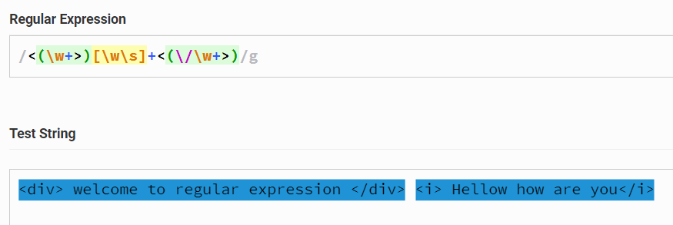

Adding back referencing. “\1” refer to group one text not the pattern.

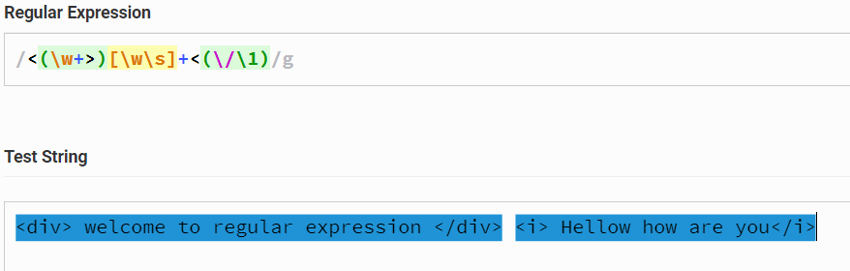

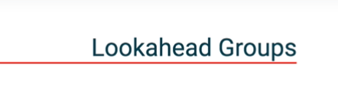

Lookahead group allows us to use particular pattern to determine a match but every thing in that group will not be part of the result. It affects what is matched but not will be the part of the result.

ie lookhead groups are the groups helps us to determine or get the match but not the part of the result.

Difference between non-capture group and Lookahed group?

Non-capture group still be the part of the result but lookahead group will not be the part of the result.

Lookahead group it starts with (?=)

Positive lookahead group match a group after the expression and will not be the part of the result.   
this says after word character we should have a “.com” to have a match.

We want a word character before the “.com” but “.com” is not part of the result.

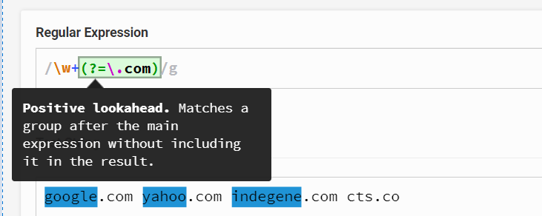

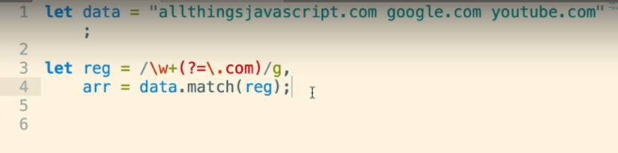

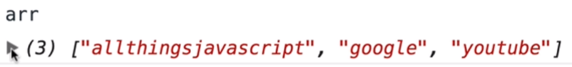

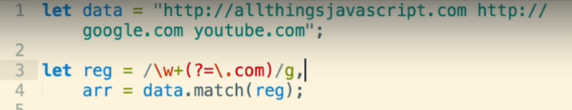



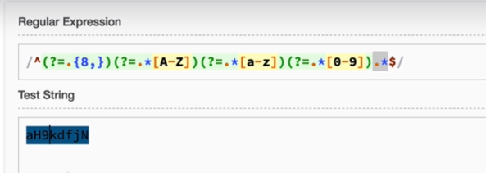

^ beginning of the string   
$ end of the string  
.* any character after the pattern

Each lookahead group check for a match from the beginning of the string if all the lookahead group satisfied or valid string is matched.

So first lookahead group is (?=.{8,}) it checks the first character in the string fails so it moves to second until it gets the 8 character or more.

Second lookahead group (?=.*[A-Z]) starts again from the beginning of the string if it finds the upper case it stops the search.  
  
same for next lookahead groups…



Negetive lookahead group just apposit to lookahead group, in negetive lookahead group will have a patten which is not part of the string.

Negetive lookahead group (?!) In below example match a string which should not have the number but one or more uppercase and one or more lowercase and length should more than 8 character.

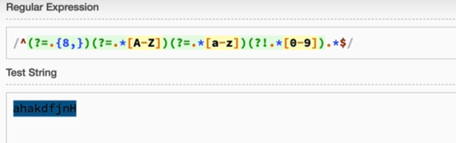

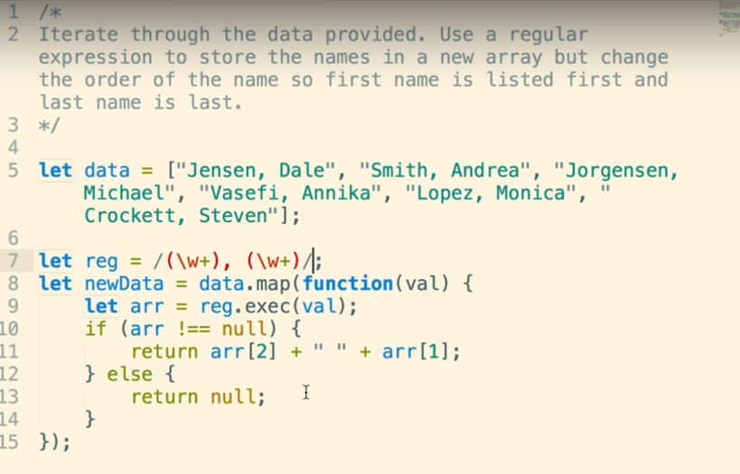





In reg exp we specify the unicode by \u followed by unicode characters.



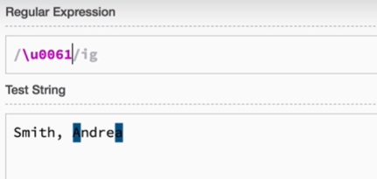

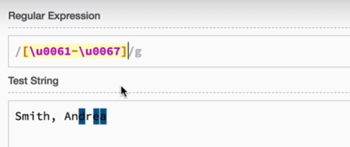

Smart codes

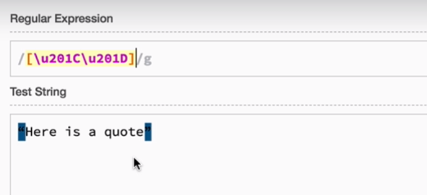

Email validation:

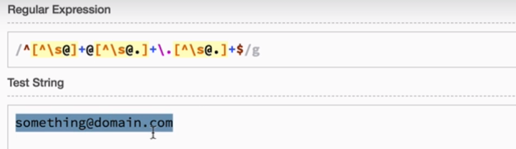

Matching a tweeter name

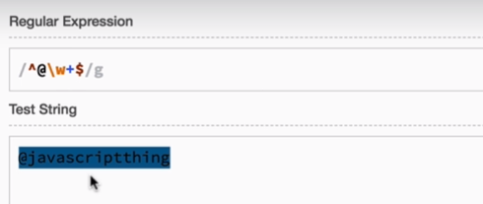

If we want to make @ optional and form JS try to access tweeter name after @ symbol

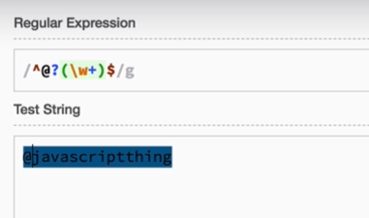

Password validation:

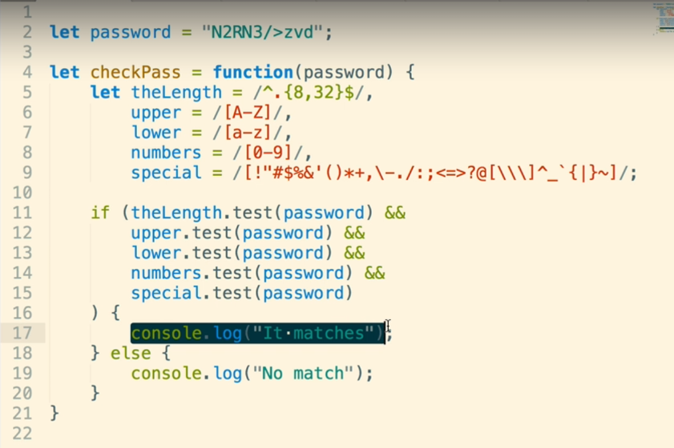

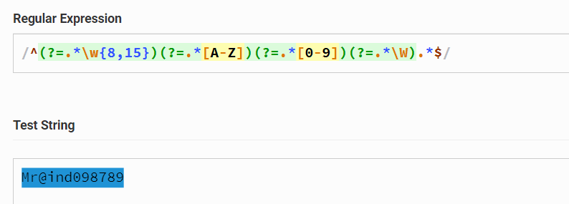

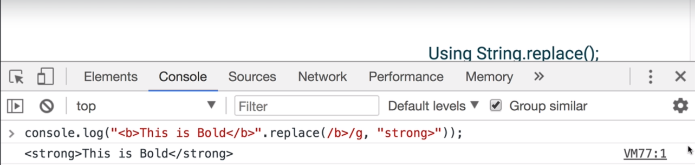

Inter change first and second names.

$1 for first matching group  
$2 for second matching group

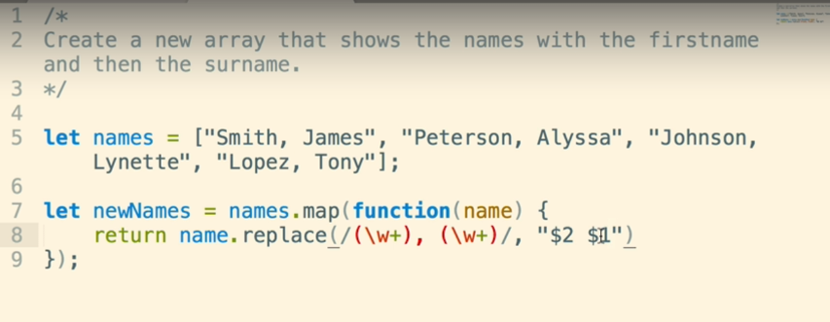

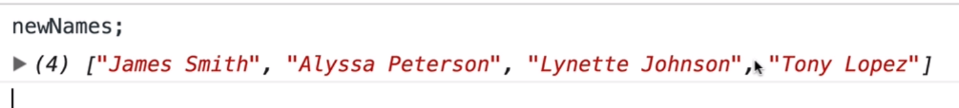

Find word next to each other.

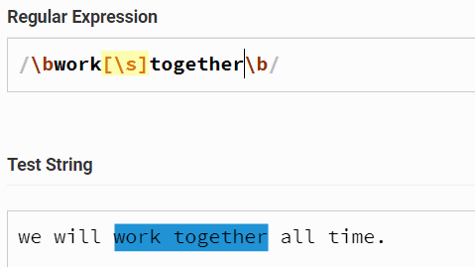

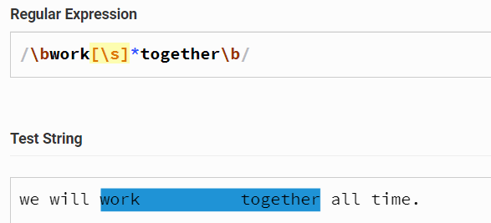

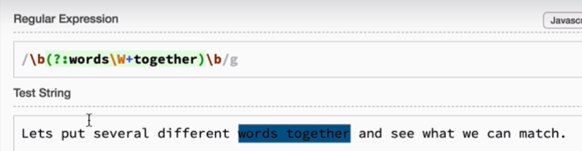

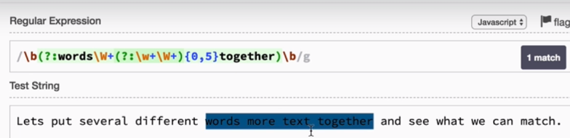

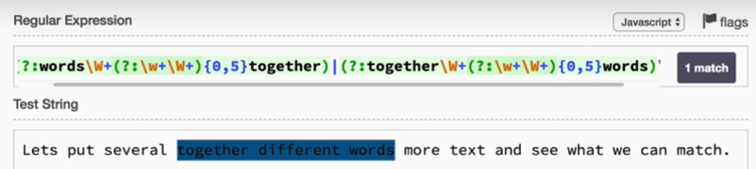

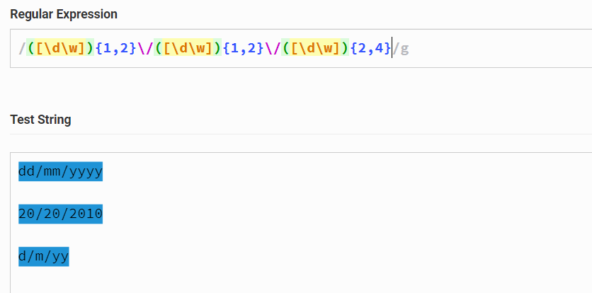

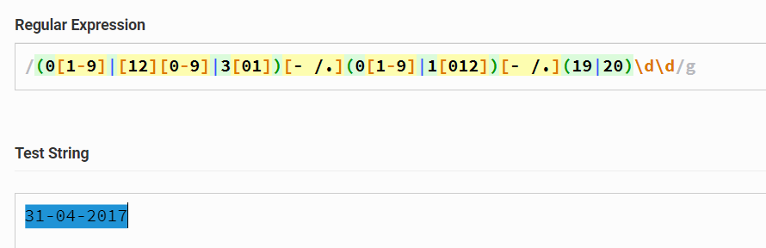

For dd, (0[1-9]|[12][0-9]|3[01])   
0[1-9] covers 01 to 09  
[12][0-9] covers 10…19…20…29  
3[01] covers 30 and 31

For mm, (0[1-9]|1[012])  
0[1-9] covers 01…09  
1[012] covers 10 11 12

For yyy, (19|20)\d\d  
either 19 followed by 2 digits, either 20 followed by 2 digits so 1999 2029

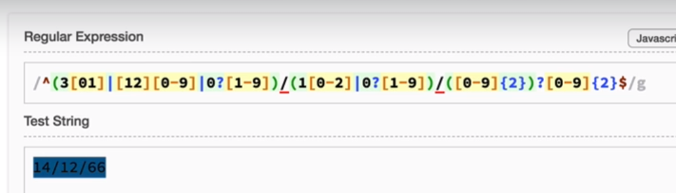

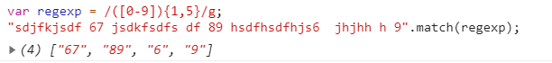

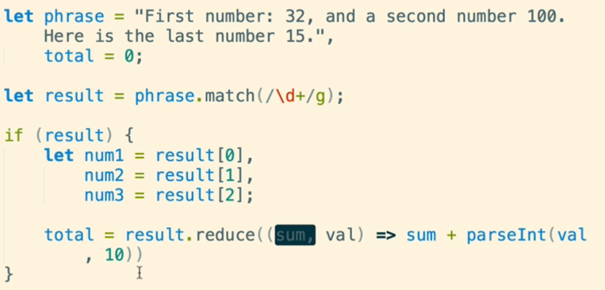

//147

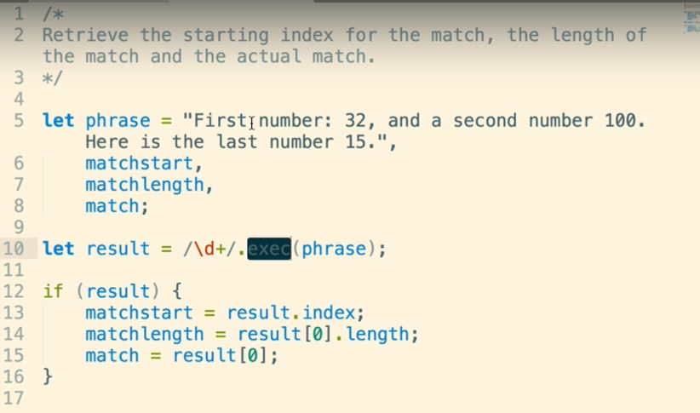

**Iteration over matches**

“lastIndex” is the regular expression property that is available for test() and exec() methods.

lastIndex provide the index position after last match.

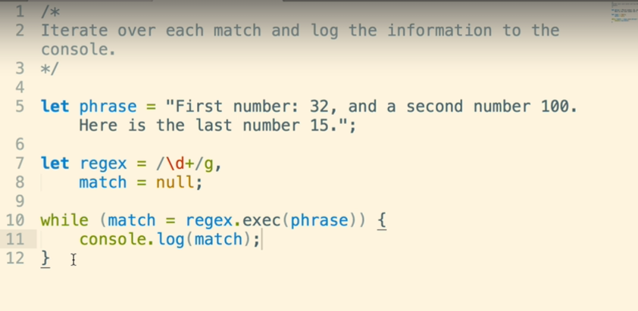

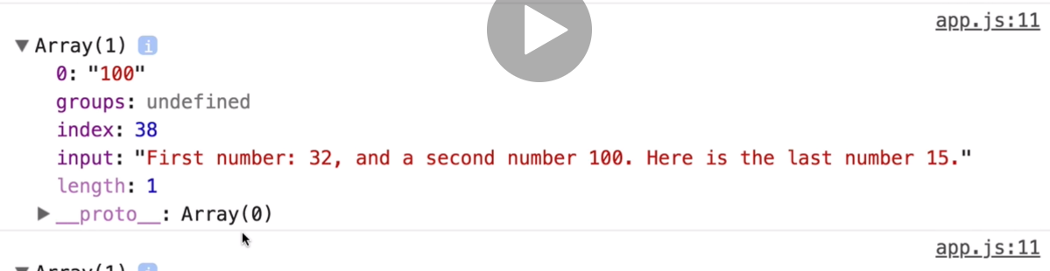

regex.exec(pharase); retuns the last index   
when ever we use /\d*/g; this is for zero or many, if any match finds zero it stucks in infinite loop to over come that we can use lastIndex property of regularexpression.

what we need to do is once it stucks in infinit loop have a condition in while loop increase the lastIndex property to next.

